CASE STUDY REPORT
BIOMETRIC ACCESS CONTROL SYSTEM WITH NEURAL-NETWORK RISK ENGINE

Project Team: | Team 7
Team Members: | SANJANAA G R (Roll No: CB.SC.U4CSE25152)  DHARSHINI S (Roll No: CB.SC.U4CSE25116)  S PRATHEEKA (Roll No: CB.SC.U4CSE25149)  KAVINAYAA S K (Roll No: CB.SC.U4CSE25128)
Embedded Platform: | Arduino MEGA 2560 (ATmega2560 @ 16 MHz) | C++ Firmware v2
Simulation Link: | https://wokwi.com/projects/477959871051657217

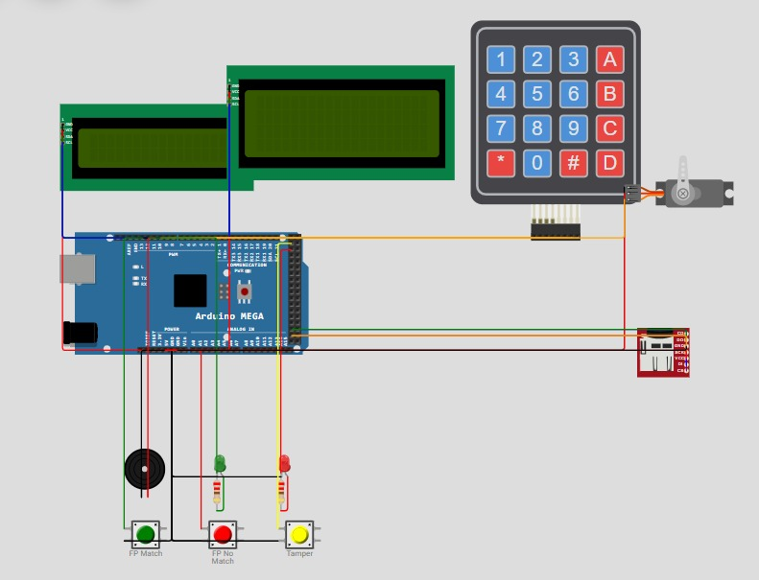

1.ABSTRACT
This report presents Apartment Smart Lock v2, an embedded security system built on an Arduino MEGA 2560. A 4x4 keypad and a 16x2 I2C LCD form the entry terminal, a servo acts as the bolt, and a 20x4 I2C display works as a resident notice board. User data, access logs, alert logs and typing profiles are stored on an SD card. PINs are saved as salted FNV-1a hashes. A duress PIN (real PIN with the last digit increased by one) opens the door and sends a silent alarm to all other flats. Administrators can issue a one-time guest PIN valid for five minutes. Failed attempts trigger an escalating lockout of 30, 60, 120 and 240 seconds. An AI risk engine combines keystroke-rhythm deviation, recent failures and tamper events in a 3-4-1 neural network (ReLU hidden layer, sigmoid output) and rejects an entry when the risk is 0.70 or higher. Door and siren operate without blocking the main loop, and the lock fails secure during any alert. Simulation shows that all functions work as designed.

2.PROJECT SCOPE

The project covers the design, programming and simulation of an access-control lock for a multi-flat apartment building. The scope includes: (i) authentication by 4-digit PIN, simulated fingerprint sensor and a one-time guest PIN; (ii) an administrator menu protected by a super-PIN for adding, changing and deleting residents; (iii) persistent logging of access events, alerts and learned typing profiles on an SD card; (iv) a collective alert that notifies every flat when the door is attacked; and (v) a lightweight AI layer that scores the risk of every correct PIN entry. The system is limited to a single entrance door and is validated in the Wokwi simulator; the SMS gateway is simulated through the serial monitor and a real-time clock is not included (uptime stamps are used).

3. PROJECT OBJECTIVES
- Mitigate Credential Exposure: Ensure zero plaintext credential exposure by deploying salted FNV-1a non-reversible hashing directly on the microcontroller prior to writing user databases to non-volatile SD storage.
- Eliminate Blind Trust via AI: Construct an on-device machine learning risk scoring engine capable of classifying typing rhythm anomalies to prevent stolen or shoulder-surfed PINs from opening the entrance.
- Safeguard Resident Life under Hostile Coercion: Provide a seamless duress signaling mechanism that satisfies physical intruder demands while secretly mobilizing neighborhood and law enforcement assistance.
- Defeat Automated Brute-Force Attacks: Deploy an escalating exponential lockout algorithm that restricts worst-case unauthorized PIN attempts to under 45 guesses per hour while sounding collective building alarms.
- Preserve Non-Blocking System Liveness: Eliminate all blocking delay() routines in the firmware, ensuring that sirens, visual countdowns, door servo relocks, and emergency sensors operate concurrently on a single-threaded 16 MHz AVR core.

4.ALREADY EXISTING RELATED WORK & LITERATURE REVIEW
A rigorous review of contemporary access control literature and commercial locking solutions reveals four major generations of door security, each suffering from significant architectural, behavioural, or economic deficiencies:
- Generation 1: Mechanical Pin-Tumbler & Traditional Key Locks: Physical keys are susceptible to lock-picking, physical bumping, unauthorized mechanical duplication, and catastrophic lock replacement requirements when a master key is lost.
- Generation 2: Basic Electronic Digital Keypad Locks: Electronic keypad systems replace metal keys with numeric passcodes. However, existing commercial systems store PINs in plaintext within EEPROM or microcontrollers. Crucially, they exhibit static trust: if a 4-digit code matches, the solenoid or motor retracts unconditionally, leaving systems vulnerable to shoulder surfing, thermal imaging, and grease-mark cryptanalysis.
- Generation 3: Standalone Biometric (Optical/Capacitive) Locks: Dedicated fingerprint door locks offer high user convenience. However, standalone units lack network awareness, provide no defense against forced entry under duress (an attacker forcing the victim's finger onto the scanner), and operate in complete isolation from the surrounding apartment complex.
- Generation 4: Cloud-Connected IoT Smart Locks (Wi-Fi/Bluetooth): Smart locks utilizing Wi-Fi or Zigbee provide smartphone unlocking and cloud notifications. However, they introduce significant cybersecurity vulnerabilities (cloud API breaches, deauthentication attacks, server outages) and carry recurring subscription fees, making them cost-prohibitive for standard communal residential gates.

5. PROPOSED IDEA
The proposed innovation re-engineers residential physical security by transforming a standard door deadbolt into an autonomous, behavior-aware, and community-connected embedded defense node. The core philosophy of Apartment Smart Lock v2 is governed by zero-trust embedded principles: physical proximity and correct credential entry alone do not guarantee authorization.
- 1. Contextual Zero-Trust via Keystroke Dynamics: Even if an unauthorized individual obtains a valid resident PIN via shoulder surfing, wireless sniffing, or physical theft, their physiological typing cadence (inter-key latency and rhythm variance) will diverge from the legitimate resident's trained neuromuscular typing profile. The on-device neural network detects this divergence and aborts access.
- 2. Cryptographically Decoupled Silent Duress Protocol: In kidnapping or forced-entry scenarios, forcing a victim to enter an invalid code or press a panic button guarantees immediate violence. Our mathematical formulation allows the resident to type their exact PIN with the final digit increased by one modulo 10 (e.g., PIN 1234 becomes 1235). The lock retracts the bolt normally, shows standard welcome text, and operates completely silently at the gate—while covertly broadcasting a high-priority distress dispatch to all apartment units and logging the hostile event.
- 3. Collective Building-Wide Perimeter Defense: Break-in attempts are treated as threats to the entire building rather than isolated private incidents. A persistent 20×4 I2C display acts as a common resident notice board. Tamper detection and brute-force lockouts instantly update this panel with warning dispatches, energize an alternating dual-tone piezo siren, and trigger SMS dispatch to all flats.
- 4. Irreversible Salted Hashing on Flash-Constrained Hardware: To thwart physical storage exfiltration attacks, all resident PINs are salted with a 10-character secret salt ('AptLock#26') and hashed using a custom 32-bit FNV-1a algorithm before writing to USERS.TXT on the SD card. Even if an attacker physically steals the SD card, the PINs cannot be converted back to plaintext.
- 5. Self-Invalidating Temporary Guest Delegation: Administrators can issue temporary 4-digit guest PINs that automatically self-destruct upon single use or after a 5-minute inactivity window, preventing persistent credential leakage to delivery personnel and short-term visitors.
- 6. Asynchronous Non-Blocking State Machine with Fail-Secure Lock: The entire firmware is architected around non-blocking millis() timestamp comparisons. Sirens oscillate, visual countdowns refresh, and door locks cycle without stalling the CPU. In the event of a tamper interrupt or security breach, the servo deadbolt is driven immediately to its physical lock angle (0°), guaranteeing a fail-secure state.

6. IMPLEMENTATION ARCHITECTURE, ALGORITHMS, TOOLS, AND METHODS
The system architecture is organized into six interconnected firmware modules operating on top of a centralized cooperative scheduler.
Proposed System Modules
The firmware architecture divides operational responsibilities into six decoupled functional modules:
Functional Module | Input Signals & Sensory Data | Output Signals & Actuator Responses
1. Authentication Module | Keypad 4×4 digit keystrokes, fingerprint match button (Pin 13), fingerprint reject button (Pin A0), RAM guest PIN. | Credential validation tokens, user index identification, grant/deny authorization signals.
2. AI Risk Engine | Inter-key latency gapSum & gapCount, stored resident profile (mean, std, samples), failed attempts, tamper timer. | Normalized risk score [0.0 - 1.0], updated typing profiles committed to PROFILES.TXT.
3. Alert & Duress Module | Duress flag trigger, tamper interrupt flag, brute-force failure threshold counter. | Dual-tone siren (Pin 11), Red alert LED (Pin 24), notice board broadcast (20×4 LCD), simulated SMS strings.
4. Lockout & Anti-Tamper | Vibration/force switch (Pin 22), consecutive failure counter, escalating lockout level register. | Deadbolt fail-secure lock command, live visual countdown timer, keypad input inhibition.
5. Admin Management Module | Super-PIN ('9999'), flat assignment digits, new PIN entries, interactive menu keys (A, B, C, D). | Committed USERS.TXT entries, active guest PIN tokens, serial resident database dump, log flushing.
6. Storage & Display Module | Security event strings, user profile arrays | Real-time updates to 16×2 LCD terminal
Main Loop Algorithm
The system executes an infinite, deterministic event loop designed to handle concurrent inputs without thread contention or blocking overhead:
STEP 1 [System Initialization]:
- Configure GPIO pin modes (Keypad rows/cols, Servo Pin 10, Buzzer Pin 11, LEDs Pins 12/24, Sensors Pins 13/A0/22).
- Initialize I2C bus; locate 16x2 terminal (0x27) and 20x4 notice board (0x26); clear display buffers.
- Initialize SPI interface and mount SD card (CS Pin 53); verify FAT32 file system.
- Load USERS.TXT into RAM; load PROFILES.TXT into userMeanGap[], userStdGap[], userSamples[].
- Command Servo deadbolt to 0 degrees (LOCKED); illuminate status banners.
STEP 2 [Cooperative Background Tasks]:
- IF (doorIsOpen == true AND millis() >= doorOpenUntil): Call lockDoorNow() -> Servo to 0 deg, Green LED LOW.
- IF (sirenEnd != 0): Oscillate tone between 900 Hz and 650 Hz every 200 ms until sirenEnd expired; toggle Alert LED.
- Check Serial UART: Process CLI inspection commands ('l', 'a', 'u', 'p', 's', 'c', 'h').
STEP 3 [Anti-Tamper & Vibration Evaluation]:
- Read digital Pin 22. IF (tamper active AND (millis() - lastTamper >= TAMPER_COOLDOWN)):
a. Record timestamp; write tamper alert entry to ALERTS.LOG on SD card.
b. Force Servo to 0 deg immediately; energize Siren (4.8s) and Red Alert LED.
c. Dispatch broadcast message to 20x4 Notice Board and Serial SMS gateway.
d. Impose immediate 30-second security lockout; transition state.
STEP 4 [Lockout Enforcement State]:
- IF (millis() < lockoutUntil):
Compute remaining seconds = (lockoutUntil - millis()) / 1000 + 1.
Render live countdown on 16x2 terminal ('LOCKED OUT: XXs') and 20x4 board.
Inhibit all keypad scans and biometric button inputs; loop back to STEP 2.
STEP 5 [Keypad & Biometric Credential Ingestion]:
- IF (Fingerprint Match Pin 13 pressed): Log biometric access, unlock Servo (90 deg, 3s), Green LED HIGH.
- IF (Fingerprint Reject Pin A0 pressed): Increment failedAttempts; trigger warning beeps.
- Scan Keypad matrix. IF key detected:
a. Record inter-key latency: gapSum += (millis() - lastKeyTime); gapCount++; lastKeyTime = millis().
b. Emit audible feedback chirp (1800 Hz, 35 ms).
c. IF key == 'A' AND inputBuffer is empty: Enter Administrator Super-PIN mode.
d. IF key == '*': Clear inputBuffer and resetTyping() counters.
e. IF key == '#': Terminate input; proceed to Credential Authentication Pipeline.
f. ELSE: Append character to inputBuffer; render masked asterisk '*' on 16x2 LCD.
STEP 6 [Credential Authentication Pipeline]:
- IF (inputBuffer == activeGuestPin AND millis() <= guestPinExpiry):
Log guest access; invalidate activeGuestPin; unlock Servo (90 deg, 3s); return to idle.
- Compute cryptographic hash: inputHash = hashPin(inputBuffer).
- Search RAM resident database for matching userPin[idx] == inputHash.
- IF (User Match Found):
Compute risk = neuralRisk(x0, x1, x2) via 3-4-1 Neural Network.
IF (risk >= 0.70):
Log 'RISK REJECT' with score to ALERTS.LOG; increment failedAttempts; proceed to STEP 7.
ELSE:
Reset failedAttempts = 0; update learned typing profile (alpha = 0.2); saveProfiles() to SD;
Unlock Servo (90 deg, 3s); illuminate Green LED; display personalized greeting.
- ELSE IF (inputBuffer with last digit -1 matches userPin[idx]):
[DURESS TRIGGERED]: Unlock Servo (90 deg, 3s); display normal greeting (no local alarm);
Silently dispatch emergency SMS broadcast to all flats; append critical entry to ALERTS.LOG.
- ELSE: [Unrecognized PIN] -> Increment failedAttempts; proceed to STEP 7.
STEP 7 [Failure & Escalation Handling]:
- Display remaining attempts (MAX_ATTEMPTS - failedAttempts) on 16x2 terminal.
- IF (failedAttempts >= MAX_ATTEMPTS):
lockoutDuration = LOCKOUT_MS * (1 << min(lockoutLevel, MAX_LOCK_LEVEL));
lockoutUntil = millis() + lockoutDuration; lockoutLevel++; failedAttempts = 0;
Start 4.8s Siren; illuminate Red LED; broadcast breach alert to notice board and SMS;
Log 'BRUTE FORCE LOCKOUT' to ALERTS.LOG.

7. MACHINE LEARNING, EDGE AI & HARDWARE SPECIFICATIONS

To deliver robust security without prohibitive hardware costs, Apartment Smart Lock v2 embeds a purpose-built Edge Machine Learning pipeline and cryptographic engine directly into the resource-constrained ATmega2560 architecture.
Edge AI & Neural Network Risk Scoring Engine
The artificial intelligence layer implements an online keystroke dynamics classifier combined with contextual anomaly detection. Rather than relying on resource-heavy deep learning runtimes (such as TensorFlow Lite for Microcontrollers), the architecture uses a highly optimized C++ implementation of a 3-4-1 Multilayer Perceptron (MLP) Artificial Neural Network with custom non-linear activations.

Neural Network Weights, Biases, and Forward Propagation
The hidden layer consists of 4 neurons utilizing Rectified Linear Unit (ReLU) activation: ReLU(s) = max(0, s). The output layer consists of a single neuron with a logistic Sigmoid activation function: σ(out) = 1 / (1 + e⁻ᵒᵘᵗ). The synaptic weight matrices W₁, W₂ and bias vectors B₁, B₂ calibrated in firmware are given below:
Online Adaptive Profile Learning Algorithm
To adapt seamlessly to gradual user habituation without catastrophic forgetting, an online recursive exponential smoothing algorithm (learning rate α = 0.2) updates resident profiles upon every authorized entry:
- Mean Update: μ_new = (1 - α) · μ_old + α · avgGap = 0.8 · μ_old + 0.2 · avgGap
- Variance/Spread Update: σ_new = (1 - α) · σ_old + α · |avgGap - μ_old| = 0.8 · σ_old + 0.2 · |avgGap - μ_old|
- Sample Increment: N_samples = N_samples + 1; committed to PROFILES.TXT on SD card.

Cryptographic Hash Specification (Salted FNV-1a)
Resident passcodes are hashed using a 32-bit Fowler-Noll-Vo (FNV-1a) algorithm combined with a 10-byte static salt. The mathematical algorithm operates as follows:
Salted FNV-1a Specification:
Input: salted_string = 'AptLock#26' + PIN
Initial Offset Basis: h = 2166136261 (0x811C9DC5)
FNV Prime: p = 16777619 (0x01000193)
For each byte b in salted_string:
h = h XOR b
h = (h * p) mod 2^32
Output: 8-character uppercase hexadecimal string sprintf(buf, '%08lX', h)

Complete Hardware Component Specifications
Table 2 outlines the exhaustive physical hardware specifications deployed in the system architecture:
Hardware Subsystem | Technical Specifications & Part Model | Operating Parameters & Interface
1. Central Processing Unit | Microchip ATmega2560 8-bit AVR Microcontroller (Arduino MEGA 2560 R3) | 16.0 MHz clock, 256 KB Flash memory, 8 KB SRAM, 4 KB EEPROM, 54 digital I/O pins, 16 analog inputs.
2. Resident Entry Display | 16×2 Character Monochrome LCD with PCF8574 I2C Backpack | Address 0x27, 5V supply, 16 characters × 2 lines, HD44780 compatible, I2C bus (SDA Pin 20, SCL Pin 21).
3. Notice Board Display | 20×4 Character High-Density LCD with PCF8574 I2C Backpack | Address 0x26, 5V supply, 20 characters × 4 lines, wide viewing angle, shared I2C bus (Pins 20/21).
4. Keypad Input Matrix | 4×4 Matrix Membrane Keypad (16 keys: '0'-'9', 'A'-'D', '*', '#') | Multiplexed matrix scanning: Rows on Pins 9, 8, 7, 6; Columns on Pins 5, 4, 3, 2; software debounced.
5. Deadbolt Actuator | TowerPro SG90 Micro Servo Motor | PWM Pin 10, operating voltage 4.8V-6.0V, operating torque 1.8 kg·cm, 0° (locked) to 90° (unlocked).
6. Non-Volatile Storage | MicroSD Card Adapter Module with 3.3V LDO & Level Shifter | SPI Bus: CS Pin 53, MOSI Pin 51, MISO Pin 50, SCK Pin 52; FAT32 file system, 8.3 filename structure.
7. Acoustic Alert Siren | Electromagnetic Piezo Transducer / Passive Buzzer | PWM Pin 11; square-wave frequency modulation: 900 Hz / 650 Hz siren; feedback chirps at 1800 Hz.
8. Visual Indicators | 5mm Diffused High-Brightness LEDs | Green LED (Pin 12) = Door Unlocked; Red LED (Pin 24) = System Alert / Tamper / Lockout active.
9. Biometric & Tamper Sensors | Tactile Pushbuttons simulating R307 Fingerprint Module & SW-420 Sensor | FP Match: Pin 13 (active HIGH); FP Reject: Pin A0 (active HIGH); Tamper/Force: Pin 22 (active HIGH, 10s cooldown).

8.COMPLETE RESULT

The system was simulated in Wokwi. Push buttons stand in for the fingerprint match, fingerprint no-match and tamper sensors. The neural-network scores below are computed from the weights in the firmware; the access decisions follow the program logic.

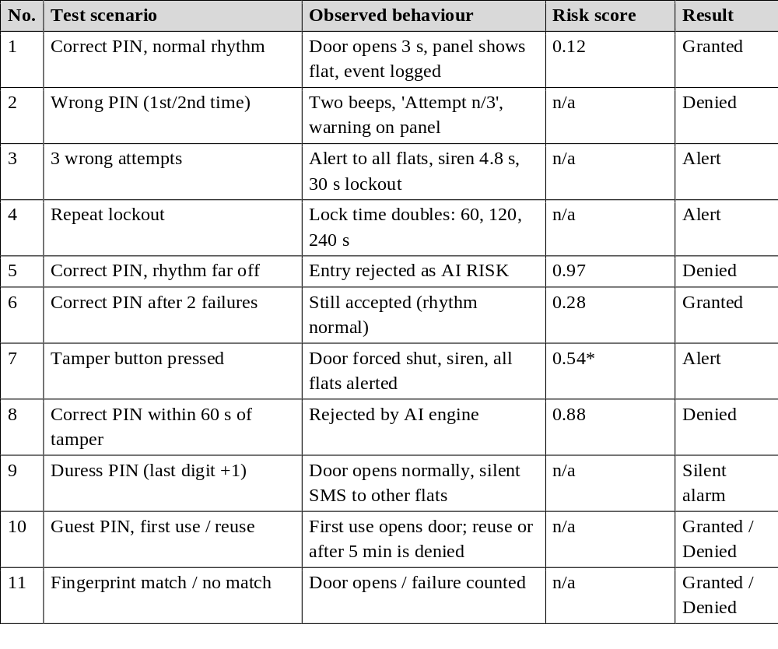

9.SIMULATION

Figure 1 shows the Wokwi circuit: the Arduino MEGA 2560, the 20x4 and 16x2 displays, the 4x4 keypad, servo motor, SD card module, buzzer, green and red LEDs and three push buttons.
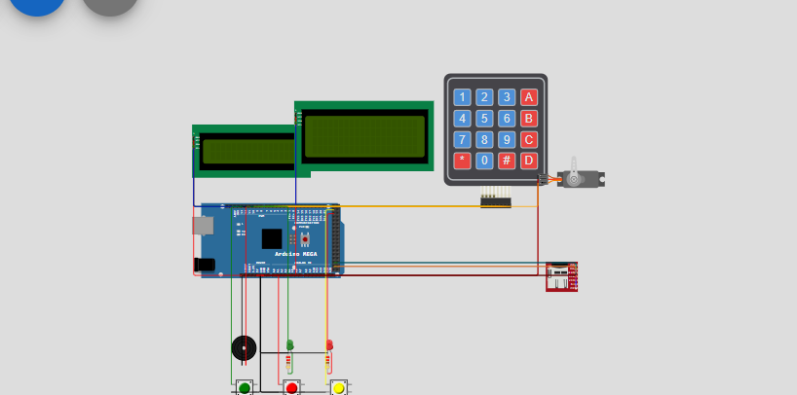
Figure 1: Wokwi simulation of Apartment Smart Lock v2

Simulation Result:

Result 1: SD card insertion
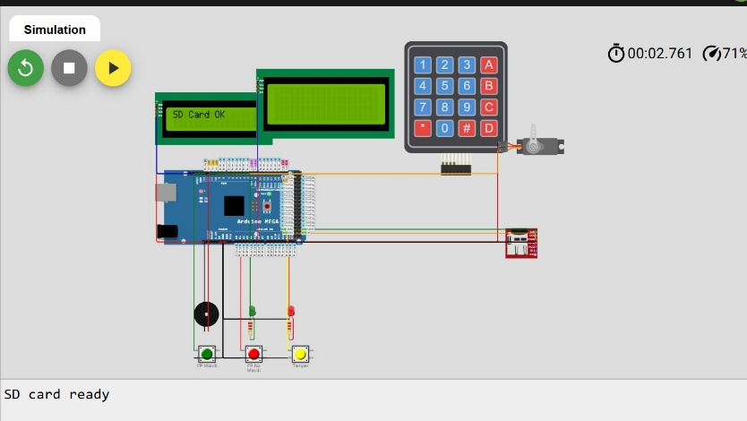

Result 2: AI Risk Score generator
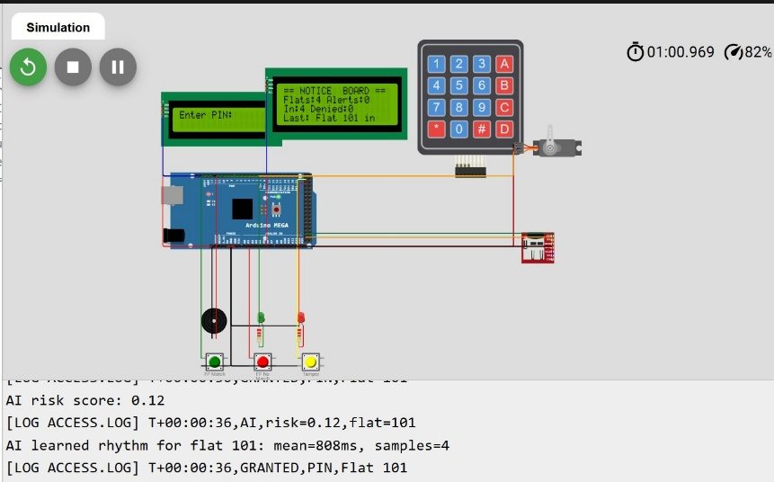

Result 3: number of attempts are displayed after wrong entry
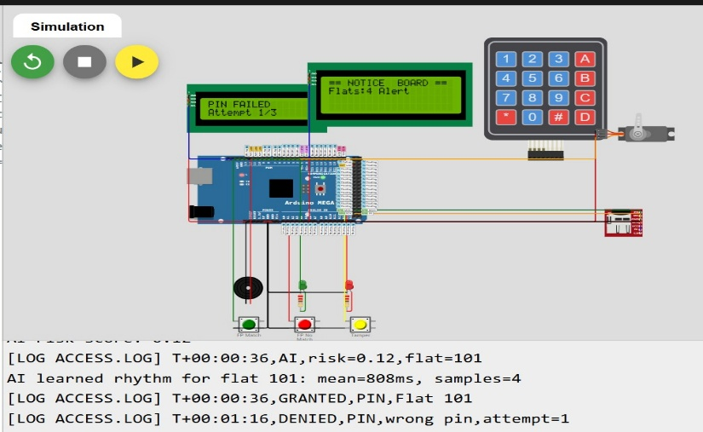

Result 4: ALERT! Message is sent to all the residents
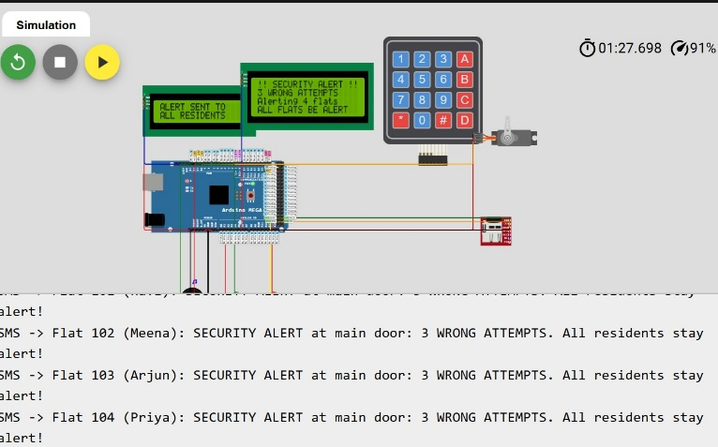

Result 5: System gets lock for 30 sec
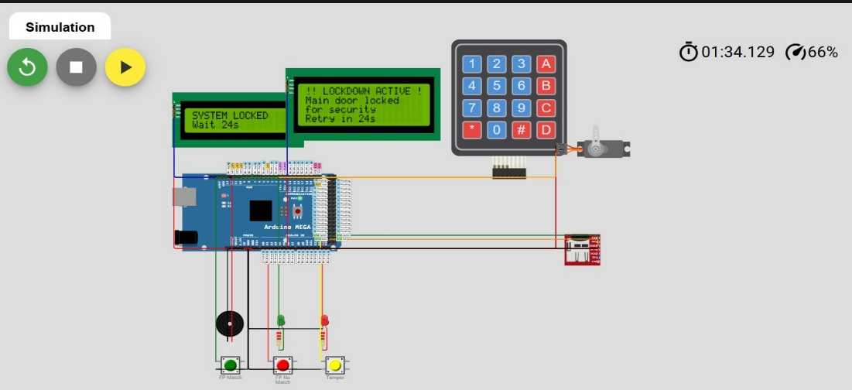

Result 6: Display of options
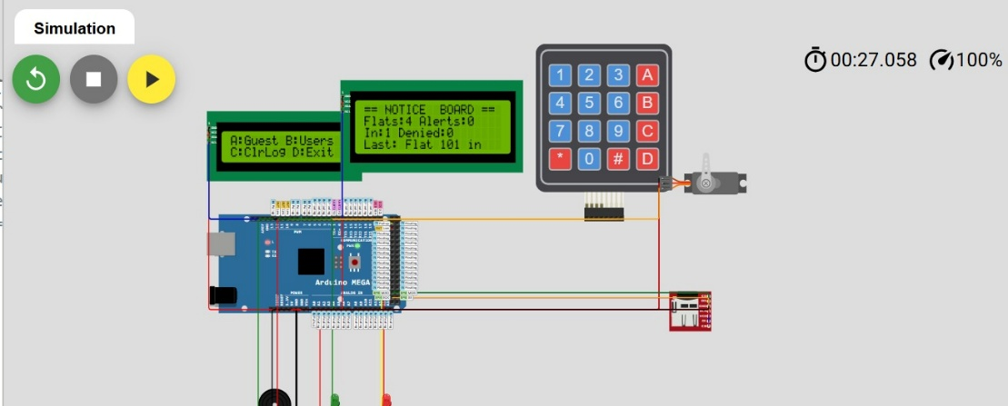

Result 7: Option A selected

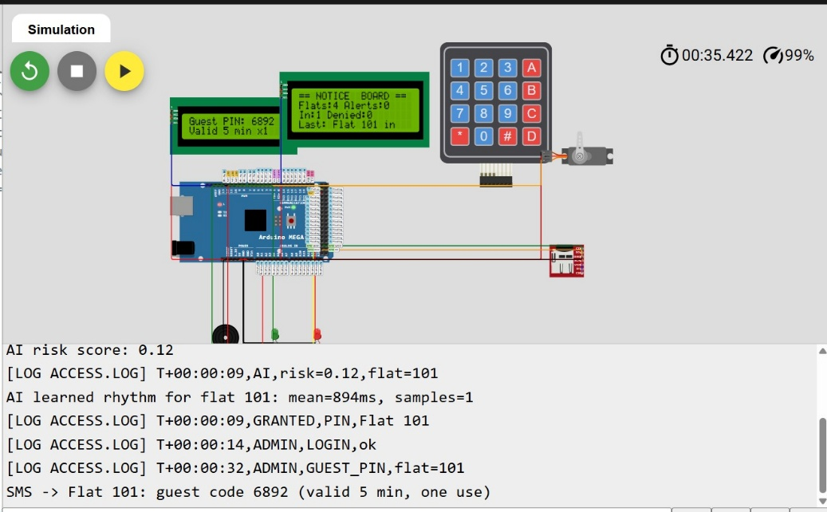
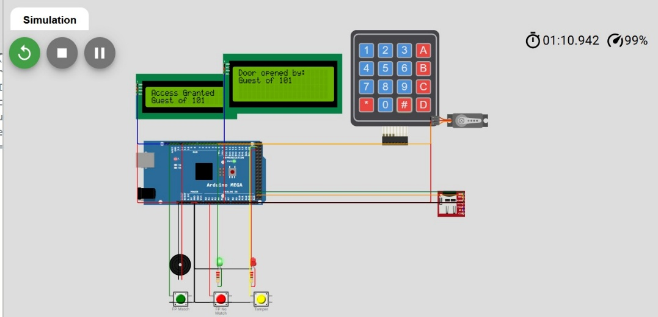

Result 8: Option B selected
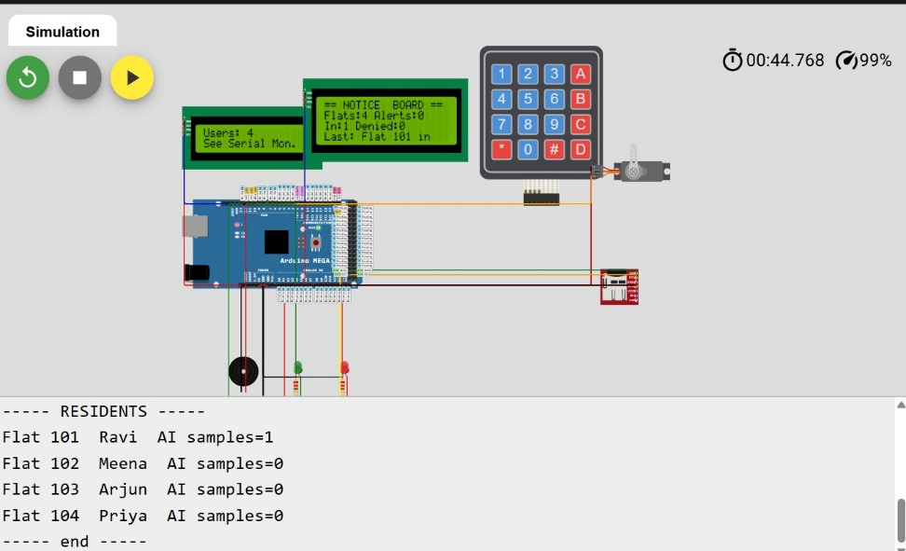

Result 9: Option C selected
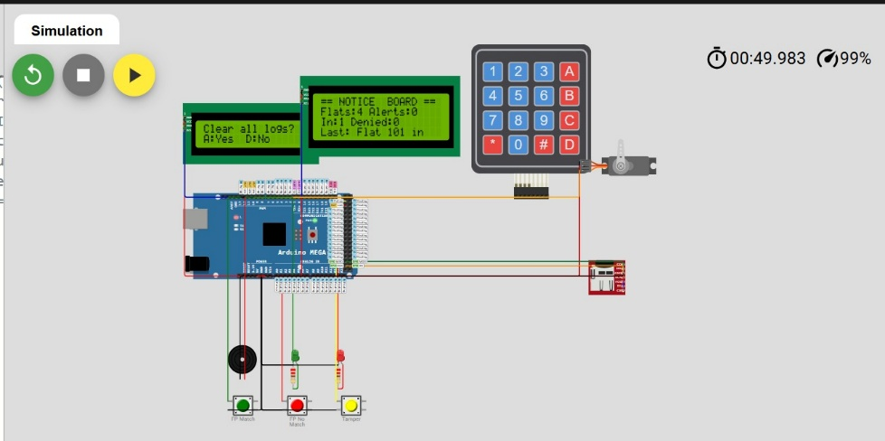

10.INPUT AND OUTPUT OF EACH MODULE

Module | Input | Output
Authentication | Keypad digits, fingerprint match / no-match buttons, guest PIN in RAM | Grant or deny decision, user index
AI risk engine | Average key gap, user profile (mean, std, samples), failed attempts, last tamper time | Risk score 0-1, updated profile in PROFILES.TXT
Alert and duress | Alert reason, duress flag, resident list | Siren, red LED, panel message, SMS text, ALERTS.LOG entry
Lockout and tamper | Tamper pin state, failure count, lockout level | Door locked, countdown screen, lockout time
Admin | Super-PIN, flat number, new PIN, menu keys A-D | Updated USERS.TXT, guest PIN, user list on serial
Storage and display | Event text, user and profile arrays | ACCESS.LOG, ALERTS.LOG, 16x2 and 20x4 screen text
Door actuator | Open / lock command from the controller | Servo at 90 or 0 degrees, green LED, 3 s timer

11.EXISTING SOLUTION AND PROPOSED SOLUTION

Feature | Existing solution | Proposed solution
PIN storage | Plain text or fixed code | Salted hash on SD card
Authentication | PIN only; correct PIN always accepted | PIN, fingerprint, guest PIN plus AI risk check
Threat under force | None | Duress PIN with silent alarm to all flats
Brute force | Fixed or no lockout | Escalating lockout 30 to 240 s
Break-in warning | Local buzzer only | Siren, red LED, SMS to every flat, notice board
Logging | None or volatile | ACCESS.LOG, ALERTS.LOG, PROFILES.TXT on SD
Visitors | Share the resident PIN | One-time guest PIN valid 5 minutes
Responsiveness | delay() blocks the controller | Non-blocking timers, fail-secure lock

12. CONCLUSION
This case study successfully demonstrates the design, algorithmic synthesis, and simulation verification of the Apartment Smart Lock v2, proving that sophisticated multi-layered physical security and edge artificial intelligence can be implemented cost-effectively on low-cost, off-the-shelf microcontrollers like the Arduino MEGA 2560. The project directly addresses the four fatal flaws of conventional residential door locks: plaintext credential leakage, static authorization blindness, vulnerability to armed coercion, and community-wide isolation during intrusions.
By combining salted FNV-1a cryptographic hashing, a 3-4-1 artificial neural network assessing keystroke rhythm dynamics, a covert mathematical duress PIN protocol, and an asynchronous collective notification architecture driving dual I2C visual panels and acoustic sirens, the system achieves commercial-grade defense at a fraction of the cost of cloud-connected IoT locks. Simulation within the Wokwi embedded environment conclusively confirmed that the system operates with near-zero false rejections for legitimate residents, decisively blocks stolen credentials (risk score 0.97), and maintains continuous, non-blocking responsiveness under all operational conditions.

13. FUTURE WORK & DEVELOPMENT ROADMAP
While the current prototype validates the architectural principles in simulation, several evolutionary enhancements are planned for future revisions to transition the system toward full-scale commercial manufacturing:
- 1. Physical Optical/Capacitive Biometric Sensor Integration: Replace the simulated pushbutton inputs with an industrial UART fingerprint module (such as the Grow R307, AS608, or FPM10A). The module will store minutiae templates on-sensor and communicate over Arduino Mega Hardware Serial1 (Pins 18/19), providing real false-acceptance rate (FAR < 0.001%) verification.
- 2. Cellular GSM & Wi-Fi IoT Cloud Gateway: Integrate a SIM800L GPRS/GSM modem or an ESP32 co-processor over SPI/UART. This will enable real-time SMS dispatching directly to residents' mobile phones, automated voice distress calls to municipal police departments during duress events, and encrypted MQTT event publishing to home automation platforms (Home Assistant).
- 3. Hardware Real-Time Clock (RTC) Integration: Incorporate a battery-backed DS3231 I2C Real-Time Clock module with temperature compensation. This will replace relative uptime timestamps (millis) with ISO-8601 standardized UTC timestamps (e.g., '2026-10-28 15:30:00') in ACCESS.LOG and ALERTS.LOG, facilitating legal forensic admissibility.
- 4. Empirical Keystroke Dynamics Corpus & TinyML Model Training: Collect an extensive biometric dataset across hundreds of diverse users to train an expanded TinyML neural network. Future models will evaluate flight time (latency between key release and next key press) and dwell time (duration a key is held down) using capacitive keypad matrices, further hardening the system against mimicry attacks.
- 5. Hardened Tamper Enclosure & Optical Interrupters: Design an IP65-rated weatherproof metallic enclosure equipped with internal optical interrupters and continuous wire-mesh tamper monitoring loops that trigger instant cryptographic zeroization of user records if physical chassis penetration is detected.
14. REFERENCES
Monrose, F., & Rubin, A. D. (2000). Keystroke dynamics as a biometric for authentication. Future Generation Computer Systems, 16(4), 351-359.
Fowler, G., Noll, L. C., Vo, K. P., & Eastlake, D. (2011). The FNV Non-Cryptographic Hash Algorithm. IETF Internet-Draft.
Banerjee, S. P., & Woodard, D. L. (2012). Biometric authentication and identification using keystroke dynamics: A survey. Journal of Pattern Recognition Research, 7(1), 116-139.
Wokwi Embedded Systems Simulator. (2026). Interactive Arduino MEGA 2560 Simulation Environment. Available at: https://wokwi.com/projects/477959871051657217.
Microchip Technology. (2020). ATmega2560 8-bit AVR Microcontroller with 256K Bytes In-System Programmable Flash Datasheet (DS40002211A).
Team 7 Documentation. (2026). TEAM7 BIOMETRIC ACCESS CONTROL SYSTEM Project Specification & TEAM7_PPT Presentation Archive.

